Ehsan Hosseinzadeh Khaligh

\*\* If you run the python on your machine, you may get error. Make sure you have older version of python to run not the newest one. 3.0 or older.

1) Run the server and server is ready to serve and accept requests.

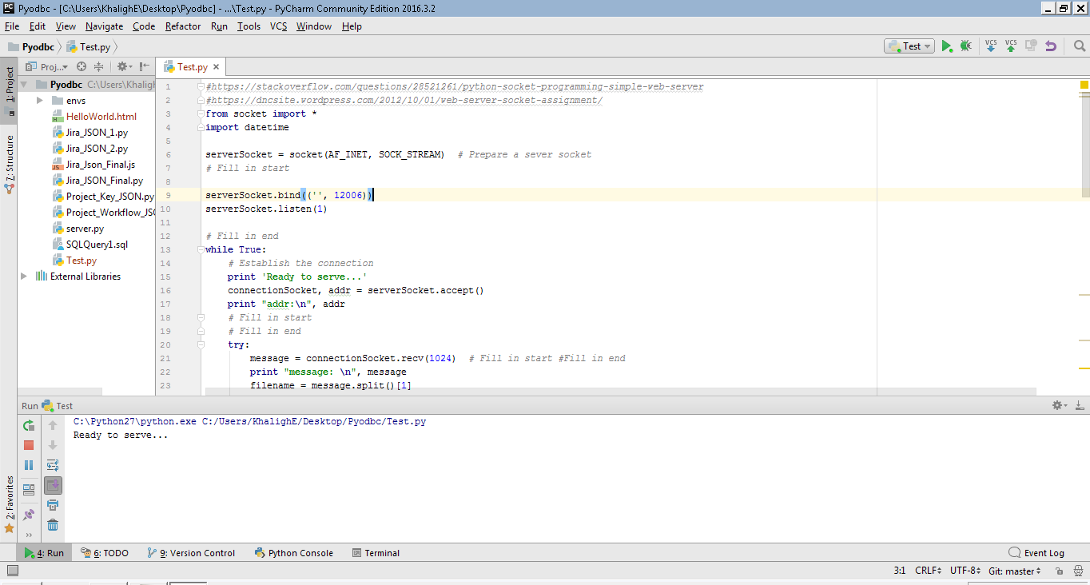

2) Open HelloWorld.htmal from the server we created.

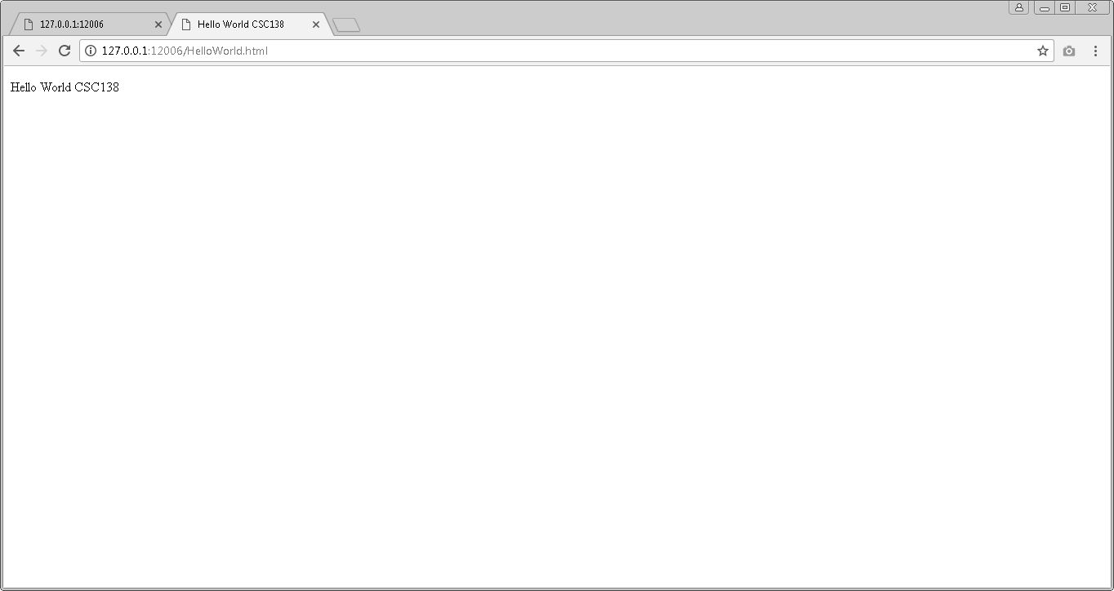

3) Shows the GET in terminal that we requested.

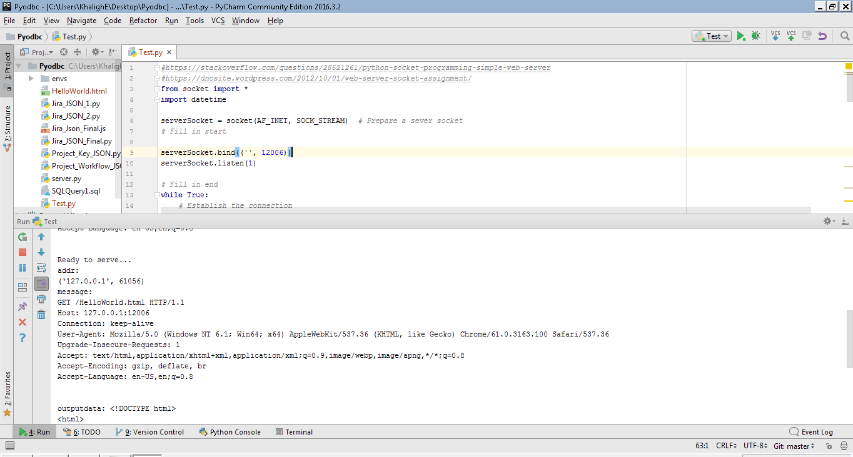

4) Requested a page that does not exist and shows 404 Not Found.

